Wenzhou Only Hearing Protectors
User Instruction
Product use: Earmuff
Model Numbers: LE701B

This device is used for protection against hearing loss; for proper use, see supervisor, or instructions, or call Wenzhou Only International Trade Co.,Ltd, No.64 West of chuangxin Road, Xialin Tangxia, Ruian, Zhejiang, China 325200 Tel:+ 86-577-66605255
Any other additional information you can get from Wenzhou Only as above address.
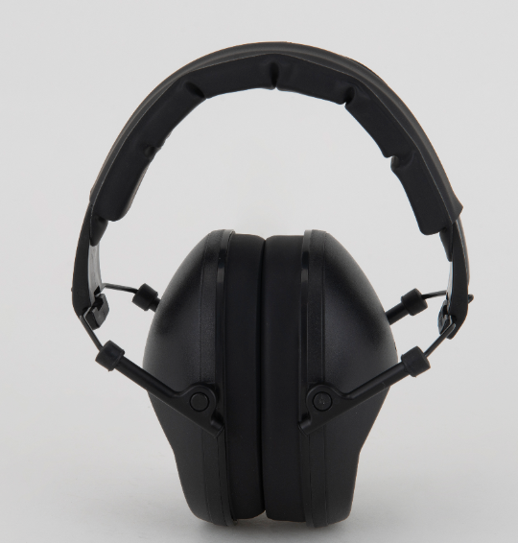

Warning notice
1，Check that the size of the earmuffs suits you, and that is perfectly adjusted when you wear it. Ensure that your headset is fitted, adjusted and maintained in accordance with the instructions of this guide. Do not wear any protective earmuffs whose size is not suitable.
2，The product is not a toy, keep the earmuffs out of reach of children.
3，Do not insert any foreign body into your headset, as this could seriously damage it.
4，Do not allow any liquid to enter your headset, since this would damage the components of your product.
5，To clean your headset, use a soft cloth soaked with a neutral solution.
6，Take care to store your headset in a clean and dry location, before and after use.
7，Your headset must be worn at all times in noisy surroundings.
8，Inspect regularly your headset to verify that it remains operational. Dot not use your earmuffs if it is damaged. Have it checked and repaired by a professional.
9，Headset and in particular cushions, may deteriorate with use and should be examined at frequent intervals for cracking and leakage, for example.
10，Be careful in a wooded environment, you may hang your earmuffs.
11，If your earmuffs moves because it falls or gets caught in branches, remember to reposition it so that it remains effective.

Contents in the package

- LE701B hearing protection
- User manual

Product presentation

LE701B is in conformity with the standard EN 352-1 : 2002 , PPE Regulation (EU) 2016/425 , which means that it meets the demands for CE marking. Its certificate was delivered by the notified body PZT GmbH – Notified body number: 1974 – Notified body address: Bismarckstraße 264 b – D-26389 Wilhelmshaven – GERMANY.
Wenzhou Only declares that the hearing protector LE-701B is in compliance with PPE regulation EU 2016/425. The full text of the EU declaration of conformity is available at the following Internet address:www.cnaolian.com
LE701B is one kind of anti-noise earmuffs. It is designed to protect your hearing from load sources such as power tools ,workshop etc.
LE701B compress loud noises that could damage your hearing. It protects you against the risk of damage to your hearing and hearing loss from repeated exposure to loud noises.
LE701B is an passive hearing protector that reduce the surrounding sound inside the hearing protector at a safe level.
The headband and the cushions are the parts of the headset which are in touch with the user. ABS and PU are an aggregate headband & cushions’ materials. Also, the headband force is not adjustable, and cushions are replaceable.

Removing / replacing cushion ring and liner:

- Remove the cushion ring by insert your fingers under the edge of the cushion ring and pull straight out.
- Assemble the new cushion rings by pressing cushion rings against the cup until it snaps into place.
Use only cushion ring and liner as-is designed for your product.

Please note

-- That the cushion ring is mounted tight against the cup.
- That nothing has been become pinched between the cup and cushion ring.

User instruction :
1. Move your hair out of the way to get a good seal between the ear muff cushions and your head. Remove earrings if they interfere with the seal of the cushion against your head.
2. Press the cups inward until they snap in around the ears.
3. Center the ear cups over both ears.
4. Slide the ear cups up or down to find the position where the ear cups completely cover your ears. When properly installed and adjusted, the cups should not touch the headgear shell or visor surround.
5. Check the seal of the ear cup cushions around the temples of your eyeglasses. If you don’t get a good seal around your glasses, you may get less protection from noise.
6. Check the fit by talking out loud. Your voice should sound hollow, like you are talking in a barrel. The noises around you should not sound as loud as they did before you put the muffs on.

Please note

- The fitting of hygience covers to the cushions may affect the acoustic performance of the earmuffs
- We recommend replacing the cushion rings and liner twice a year. Improperly replace of cushion ring may affect the acoustic performance of the hearing protector.

Technical data:

Model: LE701B
- ATTENUATION VALUES
- Frequency (Hz) | 125 | 250 | 500 | 100 | 2000 | 4000 | 8000
- Mean Attenuation (dB) | 12.3 | 15.7 | 25.1 | 35 | 31.7 | 40.1 | 40.7
- Standard deviation (dB) | 2.9 | 2.6 | 2.7 | 1.9 | 2.3 | 0.8 | 2.2
- Assumed Protection value (dB) | 9.4 | 13.1 | 22.4 | 33.1 | 29.4 | 39.3 | 38.5

H(dB) | M(dB) | L(dB) | SNR(dB)
33 | 25 | 16 | 27

Weight: 275 grams
Size: S/M/L

Materials:

- Headband Plastic
- Headband cover Fabric
- Fork Metal
- Adjustment device Plastic
- Friction part Plastic
- Cushions ring Foam and PVC

Declaration of conformity;

The full text of declaration of conformity is available at the following internet address:www.cnaolian.com

Guide for problems and solutions：
- Problem： hear surround voice clearly as wearing this earmuffs.
Solution： Adjust the ear cushion position to fully cover the ear.

- Problem： feel loose or not comfortable as wearing this earmuff.
Solution： adjust headband length and left-right ear cup position, until the ear inside the ear cup. be sure the ear
cushion is not pressed the ear.

CAUTION:
Ear muffs must be worn properly to reduce noise effectively. Read and follow all fitting and use
instructions. Failure to follow fitting instructions may result in hearing loss. Do not modify your ear
muffs. You may get much less protection and may develop a hearing loss if you bend, alter, or modify
any part of the headband, cups, inserts or ear cup cushions.

CAUTION:
Do not use the over-head ear muffs with any other respirator systems or hard hat. Failure to fit and
use ear muffs according to these instructions will reduce their effectiveness. Failure to wear hearing
protectors 100% of the time you are exposed to hazardous noise may dramatically increase your noise
exposure and your risk of developing hearing loss.
Storage：
Keep the ear muffs clean and dry and store at normal room temperature in a clean uncontaminated area before and after use.

Maintenance and Cleaning：
Clean the outside of the hearing protector on a regular basis by wiping your equipment with a damp cloth. In order to prevent electronic shock and/or damage to your equipment, DO NOT immerse in water. DO NOT use any chemical substances on this equipment

Warranty
The warranty period is 24 months, unless otherwise specified, from the date the product was purchased. The warranty validity must be supported by an invoice or cash receipt on which/ what date of purchase. If errors are discovered during the warranty period, contact your dealer. This warranty does not cover normal wear or failure due to accident, abnormal usage, neglected maintenance, improper maintenance, improper voltage, modification, intervention or a repair carried out by a non-authorized service center. The warranty is void if failure is caused by the use of accessories other than original. If the cash receipt or description of the defect is missing, the product is not covered by the warranty.



www.cnaolian.com

 1974

LE701B - 2020.10.19

